COS20019
Cloud Computing Architechture
Truong Ngoc Gia Hieu
105565520
Assignement 1 – Part A
Creating and Deploying a Web Page
Due date: This assignment will be assessed by your tutor in your tutorial in Week 4. No submission is required. You must attend this demonstration to have your assignment assessed and be eligible for future assignments.
Weighting: 5%

Preparation:
- ACF Labs 2 & 3.
- You will also need to create your own key pair and be able to access your EC2 instance via SSH using utilities like PuTTY and/or WinSCP. For more details, see Remote Access to an EC2.pdf file.
All supporting materials mentioned in this document can be found in the corresponding assignment page on Canvas

Objectives
This assignment has the following objectives:
1. Get familiar with the AWS management console.
2. Launch your own EC2 instance.
3. Deploy your first PHP web page (PhotoAlbum) on Apache web server on your EC2 instance.
4. Make cost-efficient use of your budget. Terminate any unnecessary extra resources that you created

AWS Accounts
You have a choice of accounts/environments you can use to complete the assignments in this unit.
- AWS Academy Learner Lab (recommended): accessible through AWS Canvas. Note that this is NOT the sandbox in ACA/ACF courses that you use for your weekly labs. This is a managed environment that allows your tutor to gain access to your AWS console so your work can be marked/troubleshooted. This class gives you US$100 credit. Use it carefully. This account is deleted at the end of the semester.
- Regular AWS account (NOT recommended): new AWS accounts are eligible for a free tier. This gives you more freedom, but you need to be careful as you will be charged for the services if you go outside the free tier offering. Make sure to keep track of your AWS services usage (using Billing & Cost Management Dashboard) throughout the semester to avoid paying fees. This account is on-going, but some services are no longer free after 12 months. If you choose this option, you will need to create a (read-only) IAM user and provide its credentials to your tutor so they can mark the assignment

A. TASK 1 – Launch your own Linux EC2 instance
- First and foremost, opening the Learner Lab and then wait until the circle next to the AWS is green.
Figure 1: Launching the AWS Console Home

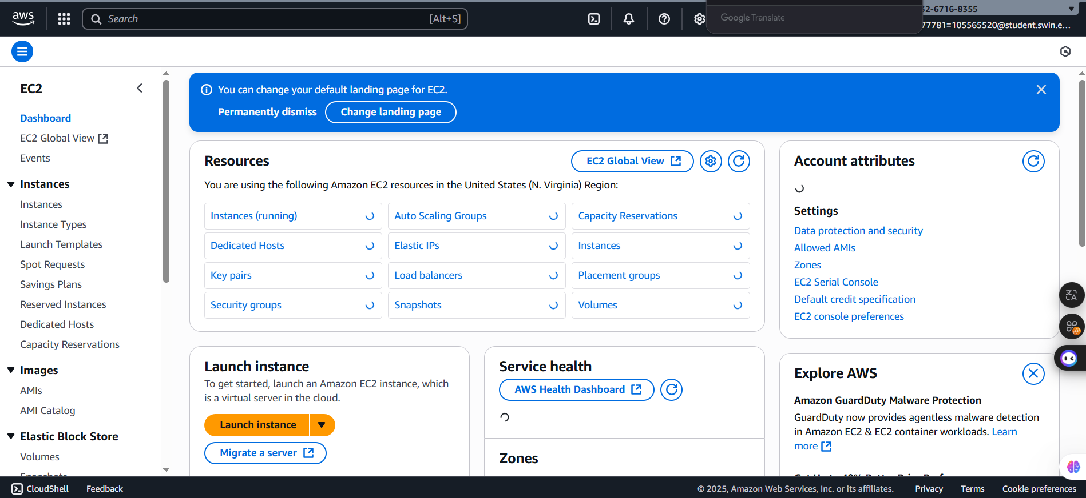
- After launching the AWS Console Home successfully, search and open the EC2 main homepage to create own key pair.
Figure 2: EC2 main homepage

- Then, configure settings for own key pair including:
+ Name: Assignment1a
+ Key pair type: RSA
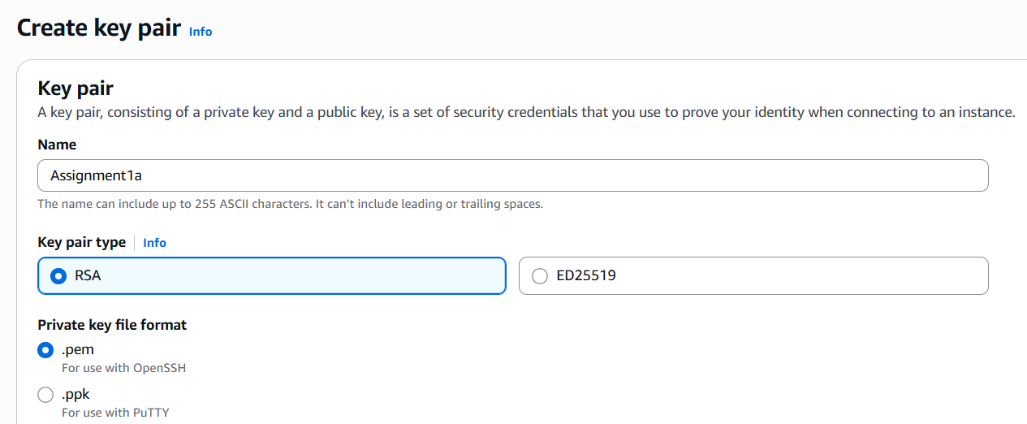
+ Private key file format: .pem
Figure 3: Key pair configuration

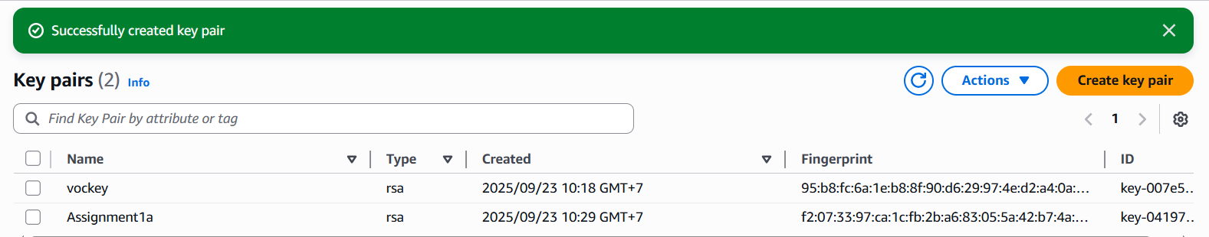
- As I expect, the own key pair named “Assignment1a” is successfully created key pair and the key pair “Assignment1a” has downloaded as “Assignment1a.pem”
Figure 4: Successfully created key pair

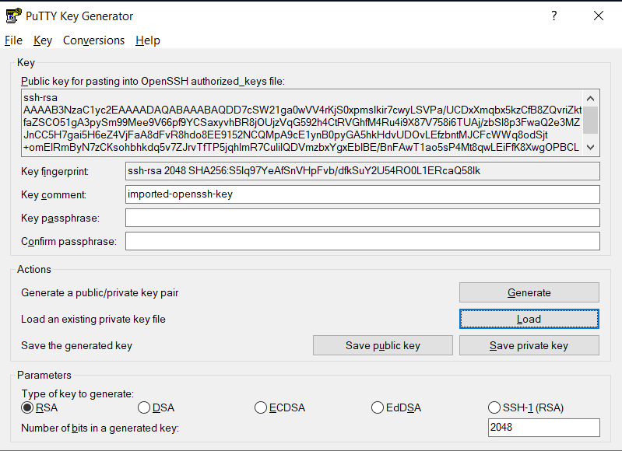
- Then, I open the PuTTY Key Generator which convert file format from .pem to .ppk
Figure 5: Convert from .pem to .ppk

- After that, the file is successfully converted from .pem to .ppk and stored in the folder named “Assignment1a”

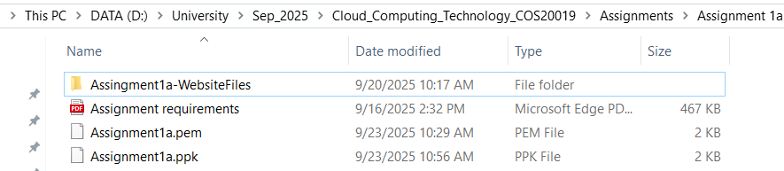
Figure 6: Converting successfully

- Next, after setting up important feature, I decide to launch the EC2 instance with following settings:
+ Amazon Machine Image (AMI): Amazon Linux 2023 AMI
+ Instance type: t2.micro
+ Key Pair: Assignment1a
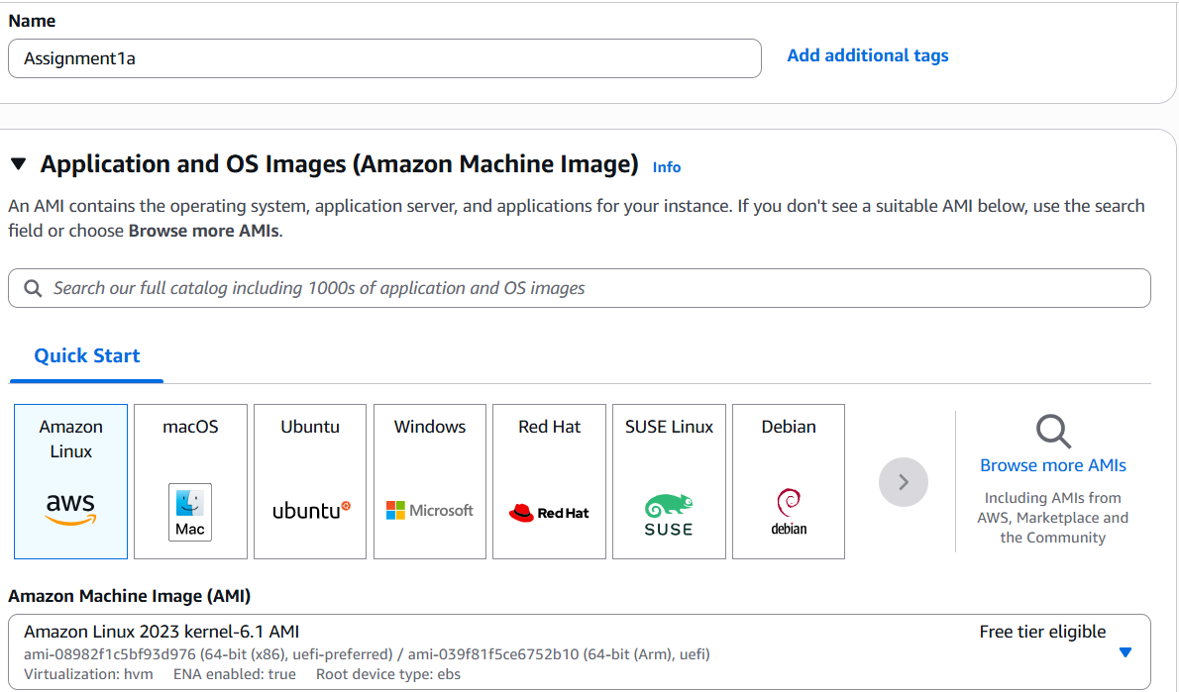
+ Security group named: “WebServer-SG”

Figure 7: Name and AMI configuration

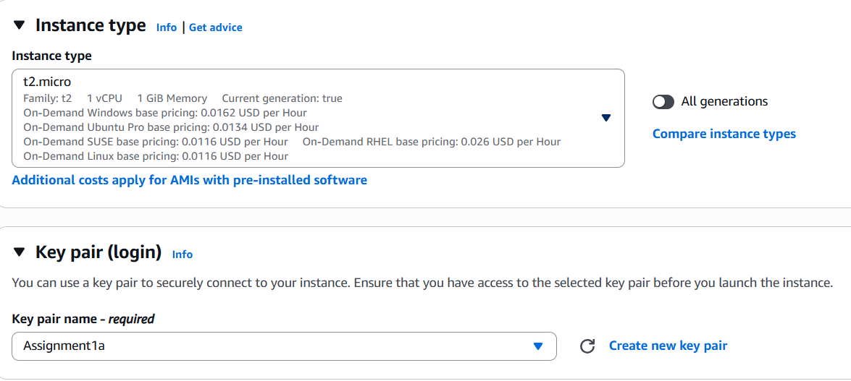
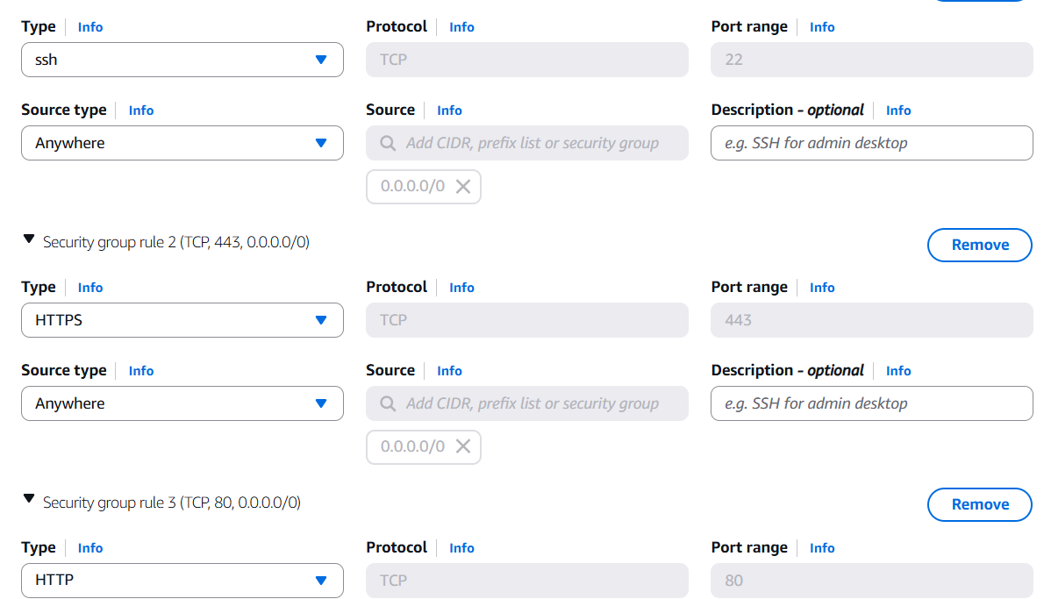
Figure 8: Instance type and Key pair configuration

Figure 9: Security group configuration

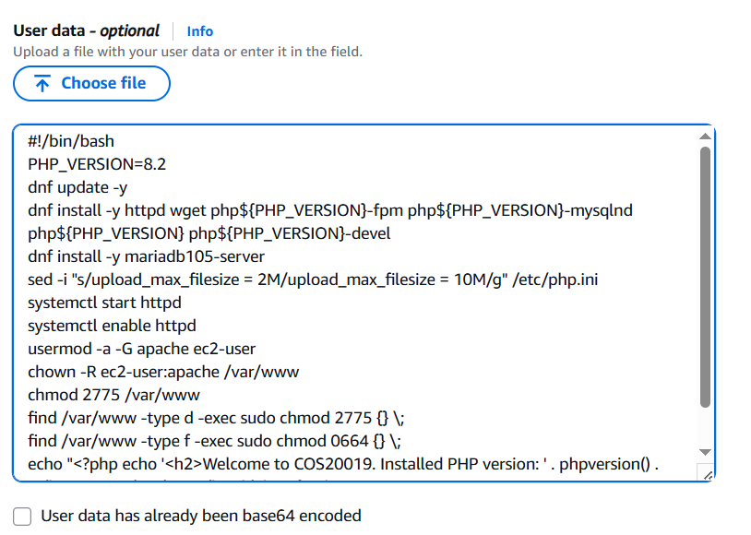
Figure 10: User Data Script

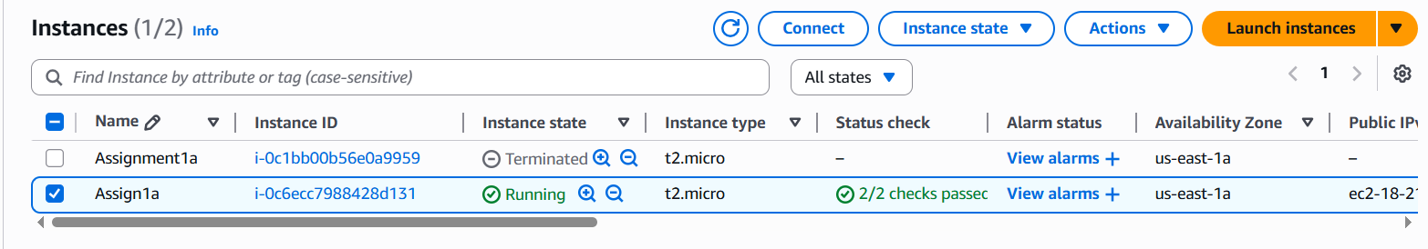
- After configuring, the EC2 instance has successfully launched
Figure 11: EC2 instance successfully launched

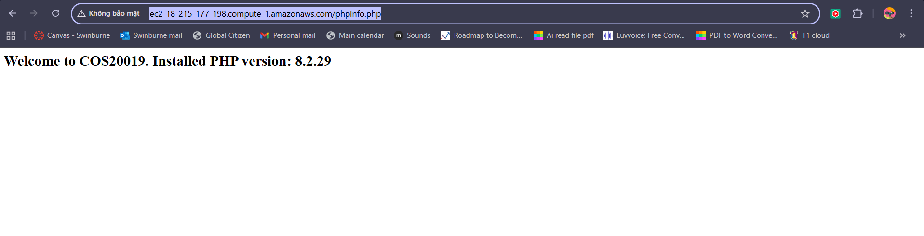
- According to the requirement, after waiting the instance launch successfully, visit the link http://ec2-18-215-177-198.compute-1.amazonaws.com/phpinfo.php and picutre below is the result.
B. TASK 2 – Create a PHP website (Photo Album)
- First and foremost, I configure these following settings to access the WinSCP:
+ Host Name: ec2-18-215-177-198.compute-1.amazonaws.com
+ User Name: ec2-user
+ Advanced => SSH => Authentication:
Then, upload the file “Assignment1a.ppk” to the Private Key Field:
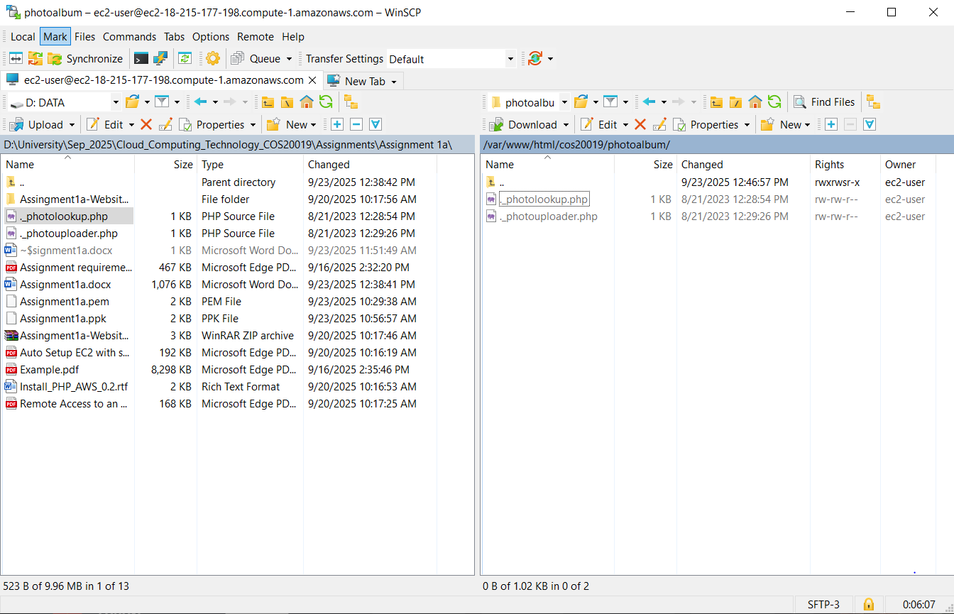
- As a result, the WinSCP has been activated

Figure 12: WinSCP

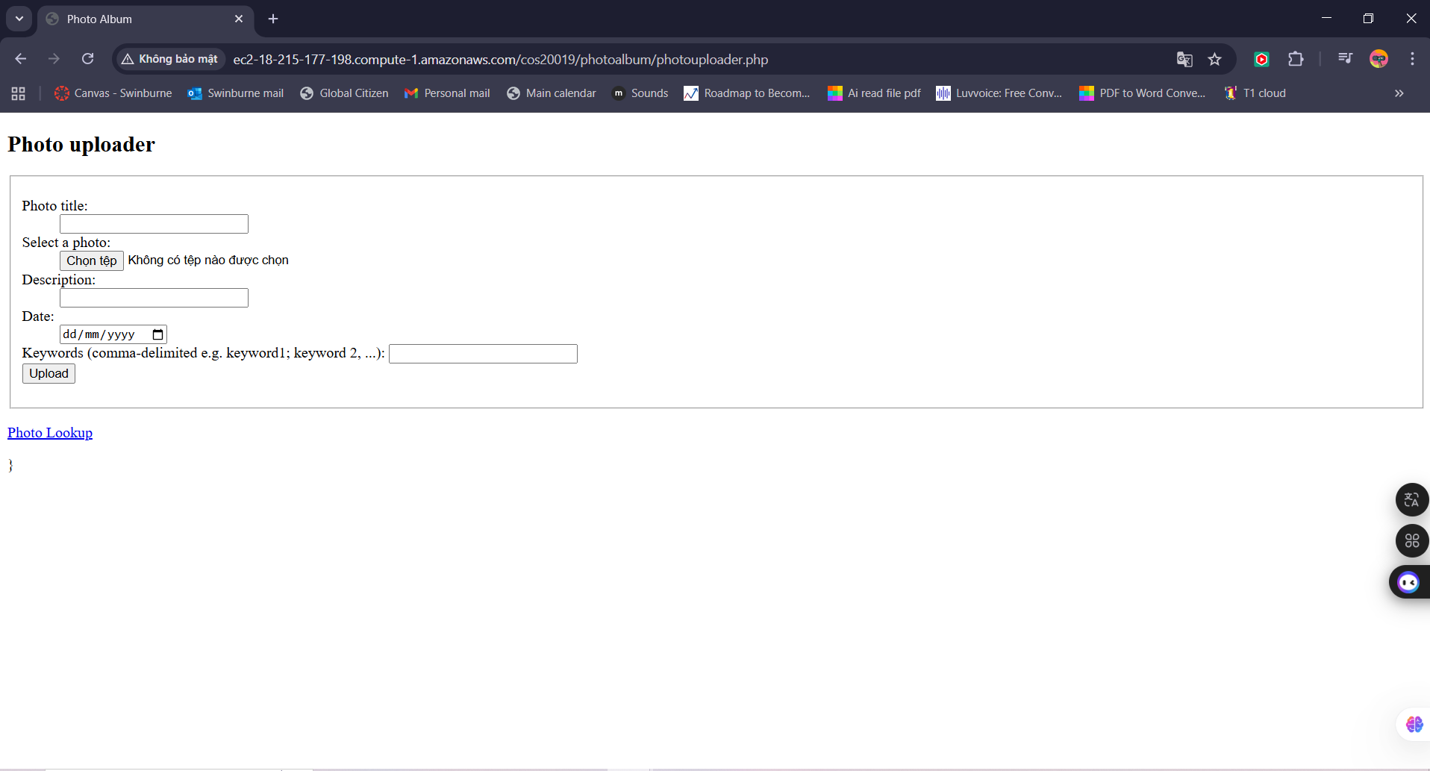
Figure 13: “photouploader.php” file

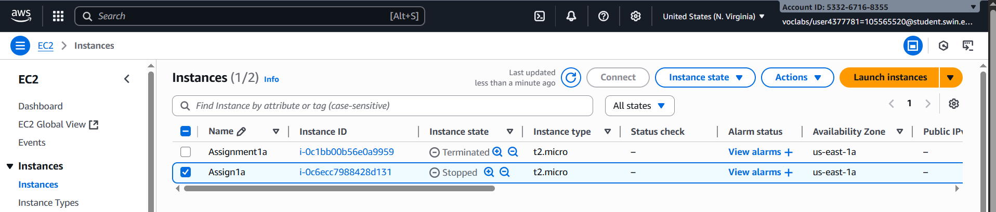
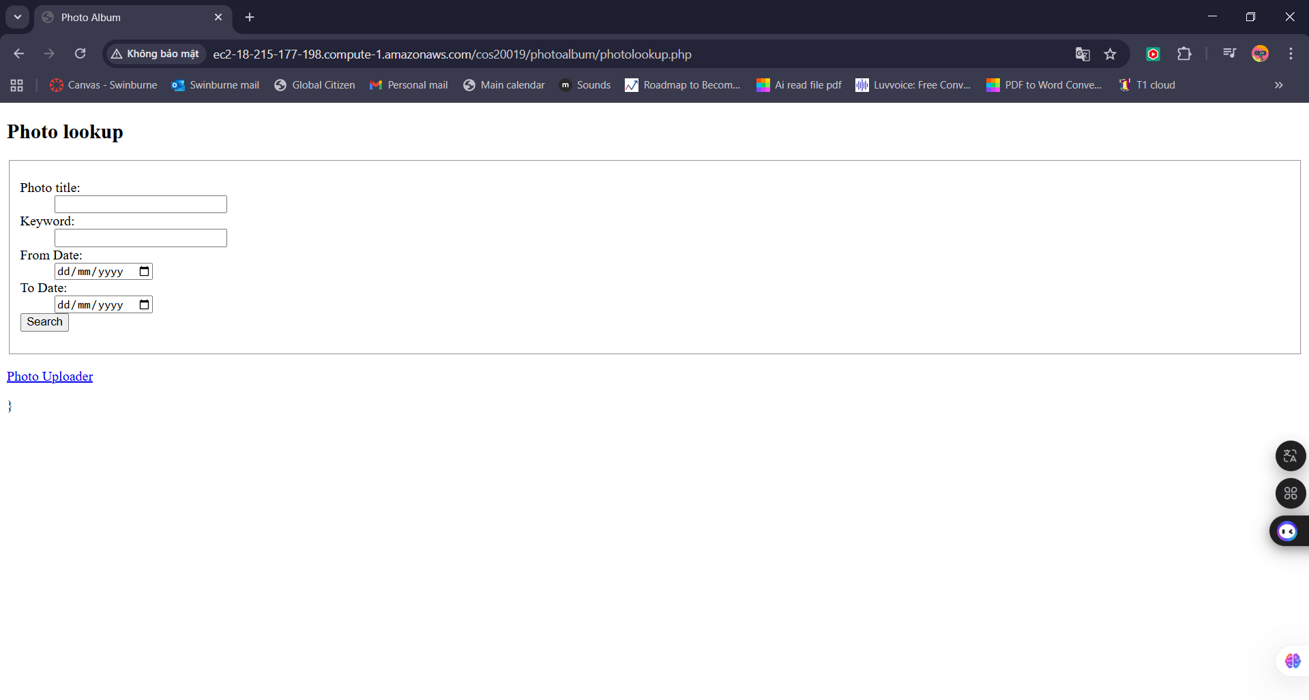
Figure 15: Stop the Assign1a instance

Figure 14: “photouplookup.php” file

